**Setup Backup Server with Amanda**

Amanda (Advanced Maryland Automatic Network Disk Archiver) is the most popular open source backup and recovery software that protects more than a million servers and desktops running various versions of Linux, UNIX, BSD, Mac OS-X and Microsoft Windows operating systems worldwide. Amanda supports tapes, disks, optical media and changers. It gives us the capability to use disk storage as backup media. Configuring, initiating and verifying a backup will complete the backup cycle within 30 minutes. Amanda has been used successfully in environments from one standalone machine to hundreds of clients. It can save you from expensive proprietary backup software (like HP DP, EMC Networker ) and those custom backup scripts that have a propensity to break at the worst times.

In this we will show;

* How can Install and configure the Amanda backup server.
* Set backup parameters.
* Verify the configuration and Verify the backup.
* Install and configure the Amanda Linux clients for backup.

## **Installing Amanda on Backup Server**

We are going to start from our first step by installing Amanda backup server on CentOS 7 server.

Update host file

**# vi /etc/hosts**  
127.0.0.1 localhost

**# yum install amanda\***

**[root@amanda ~]# amadmin --version**  
amadmin-3.3.3

## **Amanda Configurations Setup**

First we will make some directories uisng the root user, but make sure and confirm your Amanda user, that probably "amandabackup". We are using the default 'amandabackup' here to assign the ownership of the following directory structure.

**[root@amanda ~]# mkdir -p /amanda /etc/amanda**

**[root@amanda ~]# chown amandabackup /amanda /etc/amanda**

Now switch to your 'amandabackup' user and run the following commands.

**[root@amanda ~]# su - amandabackup**

**-bash-4.2$ mkdir -p /amanda/vtapes/slot{1,2,3,4}**

**-bash-4.2$ mkdir -p /amanda/holding**

**-bash-4.2$ mkdir -p /amanda/state/{curinfo,log,index}**

**-bash-4.2$ mkdir -p /etc/amanda/MyConfig**

So, all of the data will be under '/amanda' folder but you can put them wherever you would like to do. Now, we are going to add an 'amanda.conf' file at '/etc/amanda/MyConfig/' directory with the following contents.

**-bash-4.2$ vi /etc/amanda/MyConfig/amanda.conf**

org "MyConfig"  
infofile "/amanda/state/curinfo"  
logdir "/amanda/state/log"  
indexdir "/amanda/state/index"  
dumpuser "amandabackup"

tpchanger "chg-disk:/amanda/vtapes"  
labelstr "MyData[0-9][0-9]"  
autolabel "MyData%%" EMPTY VOLUME_ERROR  
tapecycle 4  
dumpcycle 3 days  
amrecover_changer "changer"

tapetype "TEST-TAPE"  
define tapetype TEST-TAPE {  
length 100 mbytes  
filemark 4 kbytes  
}

define dumptype simple-gnutar-local {  
auth "local"  
compress none  
program "GNUTAR"  
}

holdingdisk hd1 {  
directory "/amanda/holding"  
use 50 mbytes  
chunksize 1 mbyte  
}

There are a number of configuration parameters that control the behavior of the Amanda programs. All have default values, so you need not specify the parameter in amanda.conf if the default is suitable. You can find the original Amanda configuration file under the '/etc/amanda/DailySet1/' directory.

Next, we will add a 'disklist' file with a single disk list entry (DLE). The 'disklist' file determines which disks will be backed up by Amanda. The file contains include file directive or disklist entry (DLE). General usage was to describe a DLE as a partition, or file system.

**-bash-4.2$ vi /etc/amanda/MyConfig/disklist**

localhost /etc simple-gnutar-local

Save and close the file using ':wq!' when you are using 'vi' or 'vim' editor. So, we have done the configurations let's move to the next step.

## **Check Amanda Configuration**

Amanda has a nice utility called 'amcheck' which can check a configuration for you. Running it on to test configuration that gives you the results of your configurations. Note that almost all Amanda commands take the configuration name as the first argument like in our case it is "MyConfig".

Let's run the following command to check the Tape Host Server configurations.

**-bash-4.2$ amcheck MyConfig**

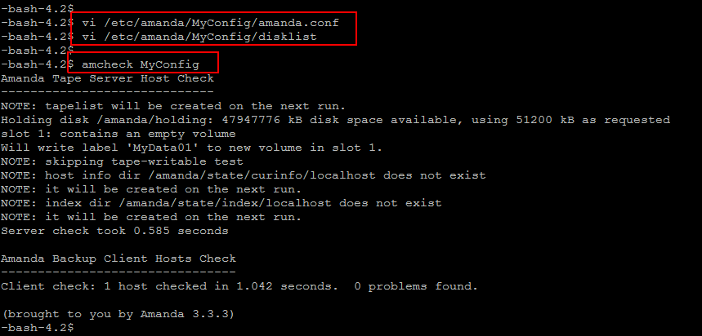

amcheck runs a number of self-checks on both the Amanda tape server host and the Amanda client hosts. On the tape server host, amcheck can go through the same tape checking used at the start of the nightly amdump run to verify the correct tape for the next run is mounted. It can also do a self-check on all client hosts to make sure each host is running and that permissions on filesystems to be backed up are correct.

You can specify many host/disk expressions, only disks that match an expression will be checked. All disks are checked if no expressions are given.

## **Run Test Backup**

The test results are positive as we have seen that there is no such error found that forced us to move forward. The tool to run backups is 'amdump'. It takes only the configuration name which doesn't print anything to the terminal in its output. Let's run as the Amanda user as shown below.

**-bash-4.2$ amdump MyConfig**

It will took few seconds then you probably will get not output. On the very next line, run the following command and that should give '0' in output. if you see something other than zero, then the backup failed.

**-bash-4.2$ echo $?**  
0

But, if you see something other than the zero, then it means you backup failed. In that case, you can see a handy report of what happened to the backup by using the 'amreport' command along with your configuration file.

**-bash-4.2$ amreport MyConfig**

amreport will generates a summary report of an Amanda backup run as shown in the below image.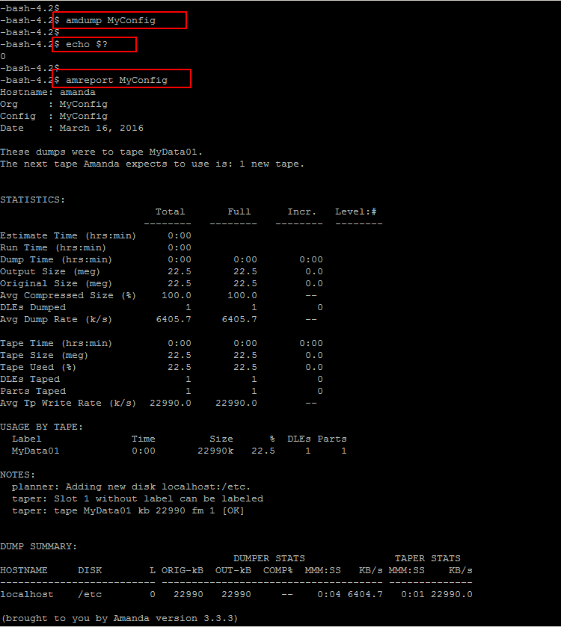

**# which amcheck**  
/usr/sbin/amcheck

amcheck can email you for problems for what we have used the '-m' flag in the crontab, and amdump will happily email you a report every night. Automation is no good if you never find out something is broken. So, just add a 'mailto' configuration to your 'amanda.conf' file.

-**bash-4.2$ vi /etc/amanda/MyConfig/amanda.conf**

mailto "user@domain.com"  
:wq!

## **Amanda Backup Client Installation**

In this section we will describes on how to install and configure our virtual machines in order to get backed up by the Amanda backup servers we have just setup in previous steps.

We are going to use another CentOS 7 server to setup Amanda Client backup installation. To install the amanda Client package run the following command.

**[root@centos-bk1 ~]# yum install amanda-client**

To restore files, you simply need to login to the client with root user. The process flow will be as below:

**Login to client > Go to the directory that you want to restore > Access Amanda server using amrecover > Select which disk > Select which date > Add into restoration list > Extract > Done**

The **'/var/lib/amanda/.amandahosts'** file used to specify Amanda server location, open the same file using your editor and add the following entry and then save the changes.

**[root@centos-bk1 ~]# vi /var/lib/amanda/.amandahosts**

localhost amandabackup  
:wq!

Copy amanda-client.conf file to configuration directory

cp /etc/amanda/DailySet1/amanda-client.conf /etc/amanda/MyConfig/.

And add below entry in amanda-client.conf file

**conf "MyConfig"**

**index_server "localhost"**

**tape_server "localhost"**

**tapedev "chg-disk:/amanda/vtapes"**

**auth "local"**

**unreserved-tcp-port 1025,65535**

save file and quit

Now go to directory /amanda/vtapes/slot01 for restoring files

**amrecover –C MyConfig**

AMRECOVER Version 3.3.3. Contacting server on localhost...

220 target AMANDA index server (3.3.3) ready.

Setting restore date to today (2017-11-30)

200 Working date set to 2017-11-30.

200 Config set to MyConfig.

501 Host target is not in your disklist.

Use the sethost command to choose a host to recover

**amrecover>listhost**

200- List hosts for config MyConfig

201- localhost

200 List hosts for config MyConfig

**amrecover> sethost localhost**

**amrecover>listdisk**

**200- List of disk for host localhost**

**201- /proc**

**201- /etc**

**200 List of disk for host localhost**

**amrecover> setdisk /etc**

200 Disk set to /etc.

**amrecover> history**

200- Dump history for config "MyConfig" host "localhost" disk /etc

201- **2017-11-28-15-15-59** 1 MyData02:1

201- 2017-11-28-15-14-35 0 MyData01:1

200 Dump history for config "MyConfig" host "localhost" disk /etc

**amrecover> setdate 2017-11-28-15-15-59**

200 Working date set to 2017-11-28-15-15-59

amrecover> ls

2013-02-05-18-29-38 web.config.txt

2013-02-05-18-29-38 tmp/

2013-02-05-18-29-38 test/

2013-02-05-18-29-38 templates/

2013-02-05-18-29-38 robots.txt

2013-02-05-18-29-38 plugins/

2013-02-05-18-29-38 modules/

2013-02-05-18-29-38 media/

2013-02-05-18-29-38 logs/

2013-02-05-18-29-38 libraries/

2013-02-05-18-29-38 language/

2013-02-05-18-29-38 joomla.xml

2013-02-05-18-29-38 installation/

2013-02-05-18-29-38 index.php

2013-02-05-18-29-38 includes

2013-02-05-18-29-38 blog

**Just want to restore blog directory, I will need to add blog into extraction list:**

|  |  |
| --- | --- |
| amrecover> add blog  Added dir /blog/ at date 2013-02-05-18-29-38  **Once added, we can extract the backup to the working directory as below:**   |  | | --- | | amrecover> extract | |

It will then restore all your files into the working directory. Just**exit** the amrecover console and you can see the restored directory will be exist there

Infofile: The file or directory name for the historical information database.

***index* *:*** Whether an index (catalogue) of the backup should be generated and saved in *indexdir*. These catalogues are used by the *amrecover* utility.

***dumpuser*:**  *"amanda"*. The login name Amanda uses to run the backups. The backup client hosts must allow access from the tape server host as this user via .rhosts or .amandahosts, depending on how the Amanda software was built.

***tpchanger****:*The tape changer to use. In most cases, only one of *tpchanger* or *tapedev* is specified, although for backward compatibility both may be specified if *tpchanger* gives the name of an old changer script.

**autolabel :**  When set, this directive will cause Amanda to automatically write an Amanda tape label to most volume she encounters.

**tapecycle:** Specifies the number of "active" volumes - volumes that Amanda will not overwrite. While Amanda is always willing to write to a new volume, it refuses to overwrite a volume unless at least '*tapecycle* -1' volumes have been written since.

**dumpcycle:** The number of days in the backup cycle. Setting this to zero tries to do a full backup each run.

**filemark:** How large a file mark (tape mark) is, measured in kbytes. If the size is only known in some linear measurement (e.g. inches), convert it to kbytes using the device density.

**Chunksize**: Holding disk chunk size. Dumps larger than the specified size will be stored in multiple holding disk files. The size of each chunk will not exceed the specified value. However, even though dump images are split in the holding disk, they are concatenated as they are written to tape, so each dump image still corresponds to a single continuous tape section.